# Case Study: CO Existing CPQ Systems

**CPQ Systems Chosen:**

1. **Apttus CPQ -** Business Unit 1
2. **Steel Brick CPQ-** Business Unit 2

Assuming that we are going to transition from from Apttus CPQ to Steel brick CPQ.

## Opportunity Object Setup for Business Units

1. A sales process with two record types is created.

Two record types , one for each business units, Business Unit 1 and Business Unit 2 are created.

Two separate layouts are assigned to each business unit with user navigation supporting quote creation in respective CPQ systems.

## Installation and permissions:

1. Apttus CPQ packages are installed in the org for admins
2. Steel Brick CPQ is also installed in the same org for admins
3. Business units 1 access the Apttus CPQ application using the following permission sets.
   * Apttus CPQ User + Order
4. Business Unit 2 access the steel brick CPQ application using the following permission sets
   * Salesforce CPQ User

|  |
| --- |
| Walk Through Scenario: ACME Media Offers the following services   1. Television, 2. Internet and 3. Telephone service and 4. Home Security.   using a bundle. I will walk through the product setup, pricing setup, Quote Creation , opportunity sync and order creation using both the CPQ systems for this imaginary use case. Apttus CPQ: Opportunity Creation, Quote Creation , Pricing. |

**[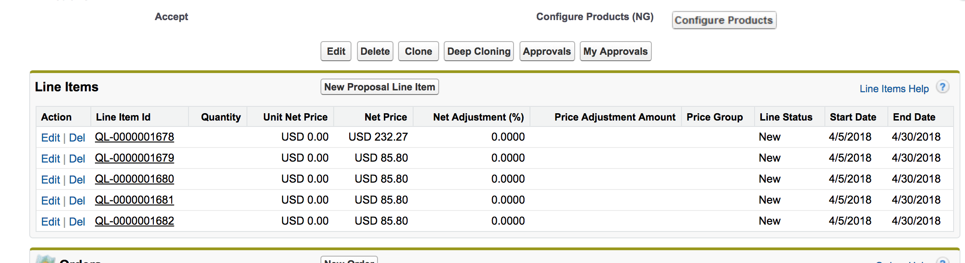](https://na74.salesforce.com/0PSo0000000IKRc)**

**[](https://na74.salesforce.com/0PSo0000000IKRc)**

### [Apttus Product and pricing Model](https://na74.salesforce.com/0PSo0000000IKRc)

[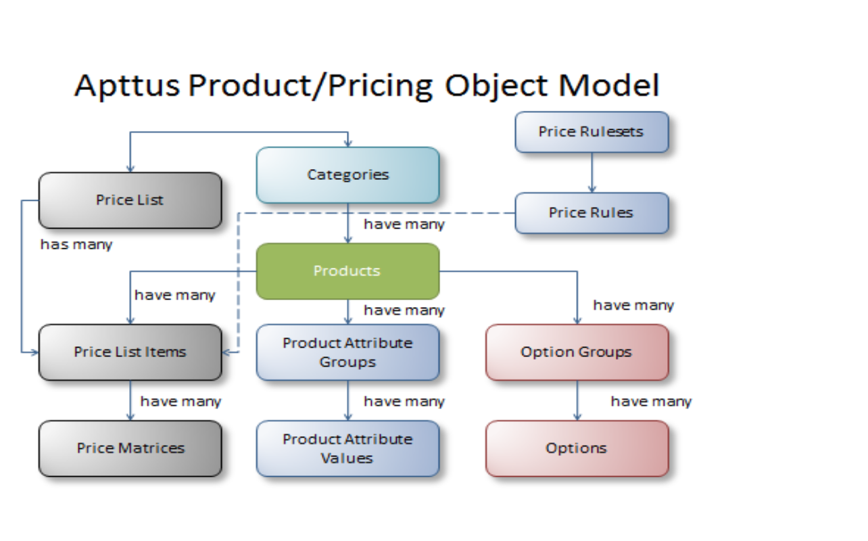](https://na74.salesforce.com/0PSo0000000IKRc)

### [Apttus Transaction Model:](https://na74.salesforce.com/0PSo0000000IKRc)

[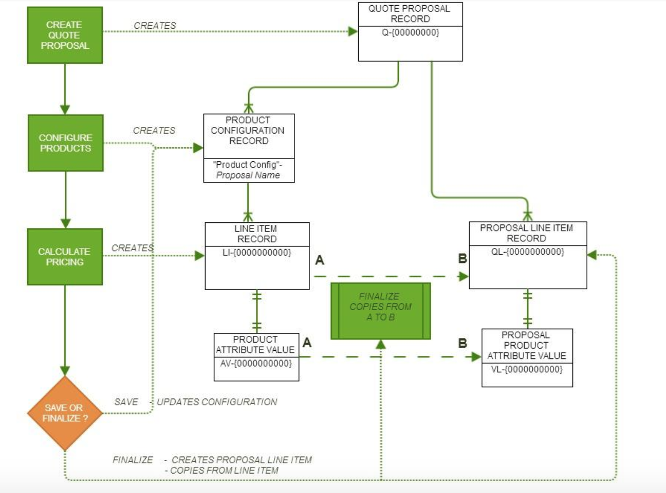](https://na74.salesforce.com/0PSo0000000IKRc)

## [Steel brick:](https://na74.salesforce.com/0PSo0000000IKRc)

### [Product Setup:](https://na74.salesforce.com/0PSo0000000IKRc)

1. [Create the bundle product HD Bundle](https://na74.salesforce.com/0PSo0000000IKRc)
2. [Add the features and Options](https://na74.salesforce.com/0PSo0000000IKRc)
   1. [HD Television](https://na74.salesforce.com/0PSo0000000IKRc)
   2. [HD Telephone](https://na74.salesforce.com/0PSo0000000IKRc)
   3. [HD Internet](https://na74.salesforce.com/0PSo0000000IKRc)
   4. [Home security](https://na74.salesforce.com/0PSo0000000IKRc)

[3. Add a standard price and add the products to the pricebook chosen on opportunity.](https://na74.salesforce.com/0PSo0000000IKRc)

### [Steel brick : Product and Pricing model :](https://na74.salesforce.com/0PSo0000000IKRc)

[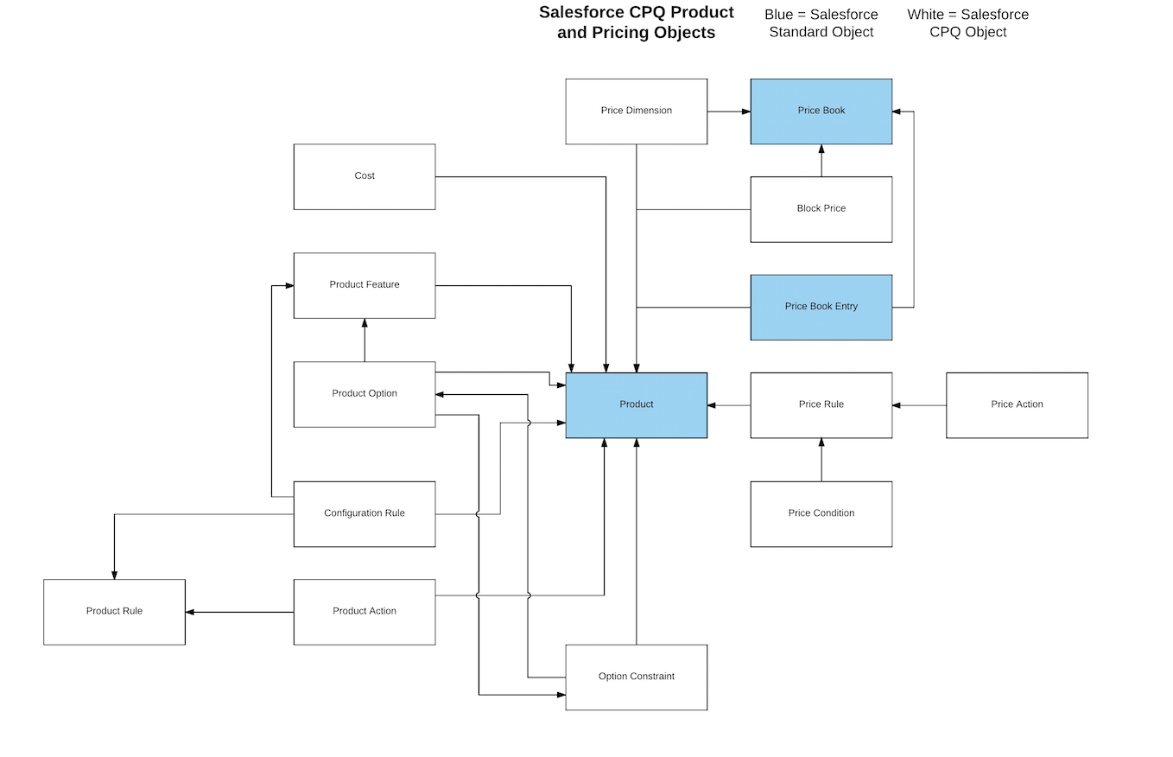](https://na74.salesforce.com/0PSo0000000IKRc)

### [Steel Brick Opportunity and Quote Creation , Pricing and Opportunity Sync:](https://na74.salesforce.com/0PSo0000000IKRc)

1. [Create An Opportuity using Business Unit 2 Record type](https://na74.salesforce.com/0PSo0000000IKRc)
2. [Select the required fields.](https://na74.salesforce.com/0PSo0000000IKRc)
3. [Create a quote from the related list](https://na74.salesforce.com/0PSo0000000IKRc)

[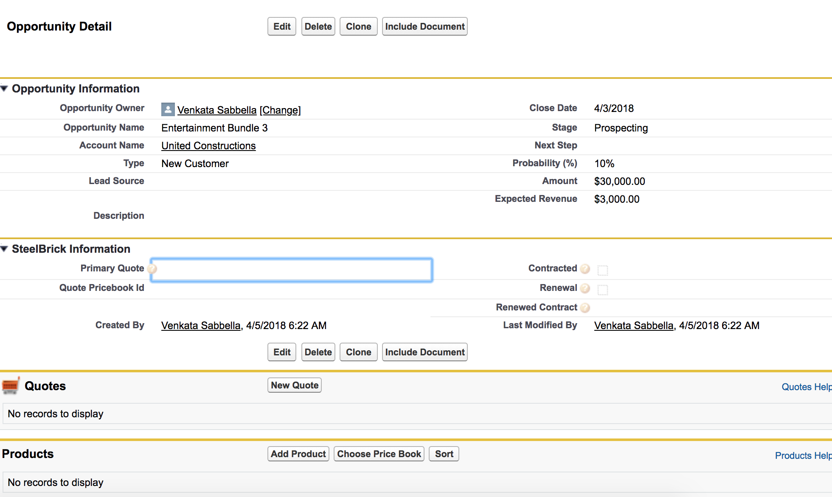](https://na74.salesforce.com/0PSo0000000IKRc)

[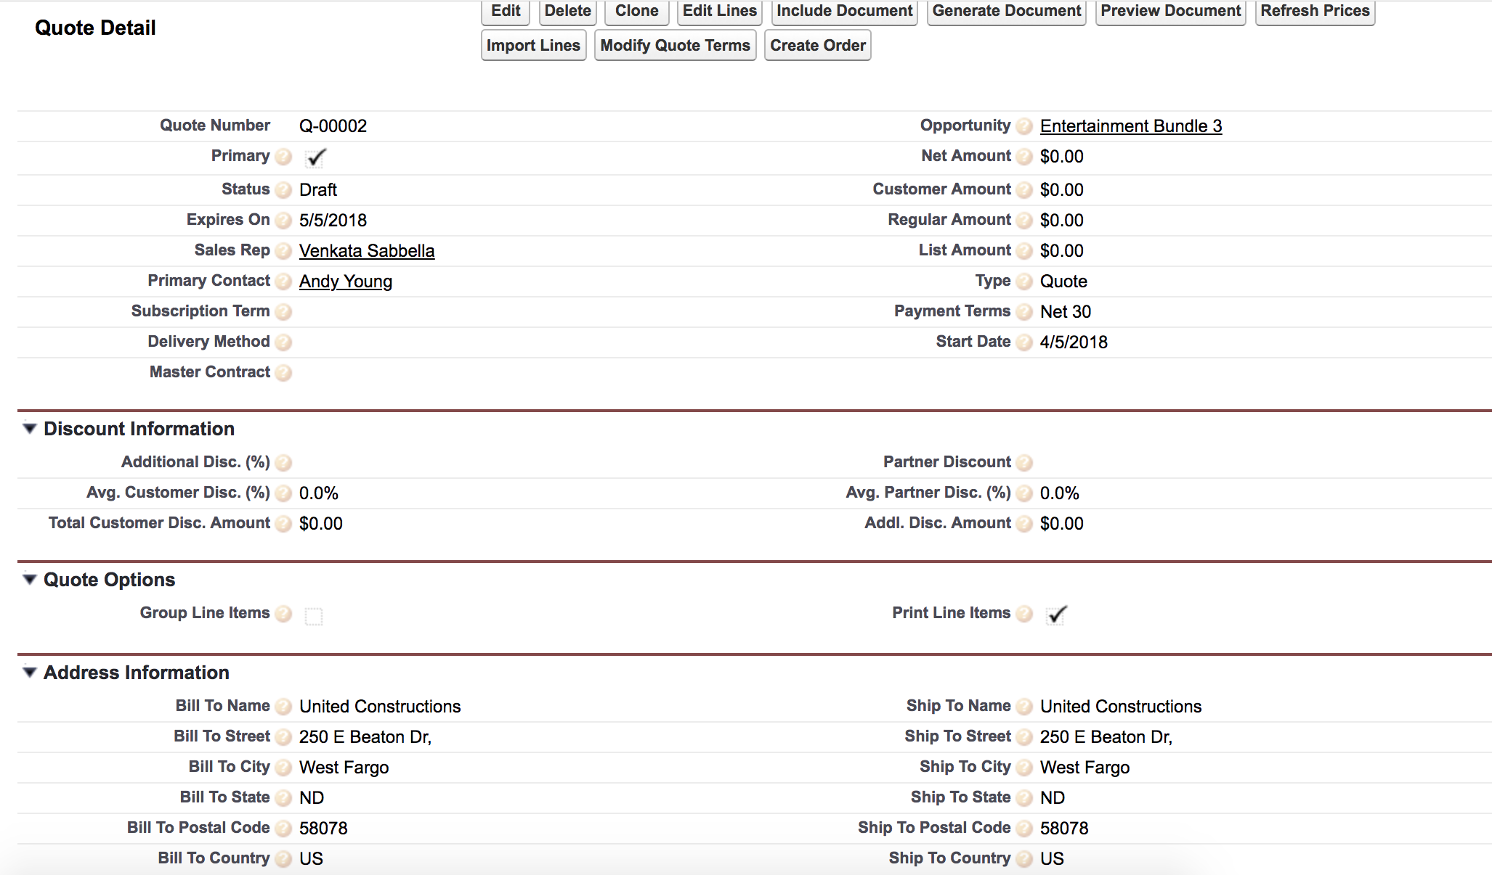](https://na74.salesforce.com/0PSo0000000IKRc)

[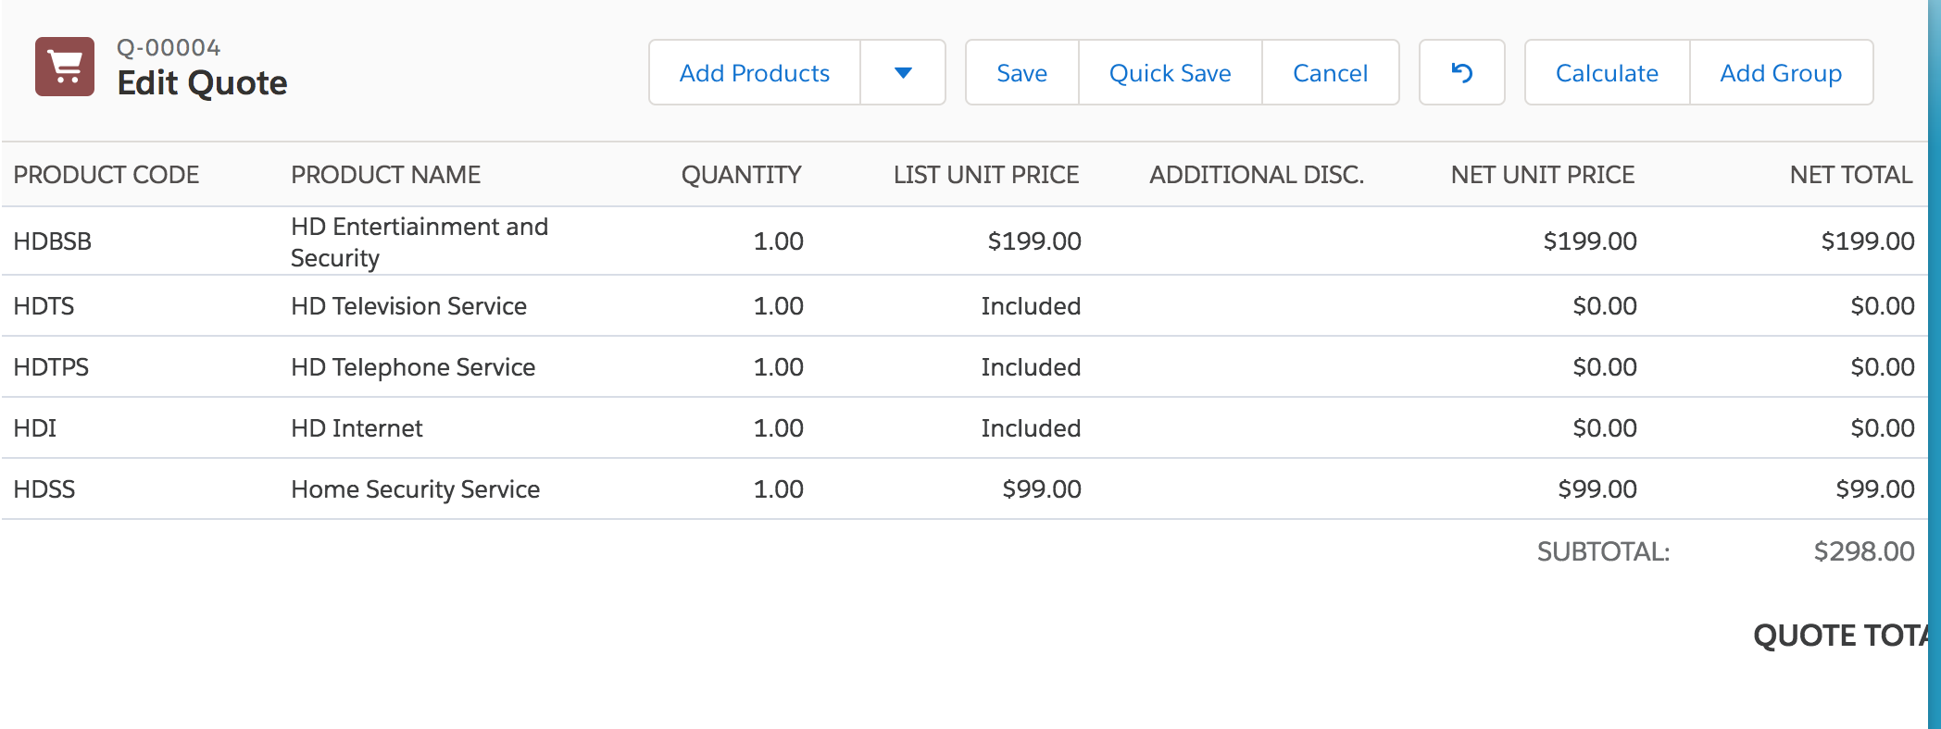](https://na74.salesforce.com/0PSo0000000IKRc)

[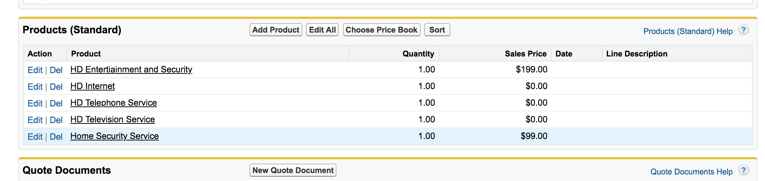](https://na74.salesforce.com/0PSo0000000IKRc)

[Salesforce CPQ Transactional Objects:](https://na74.salesforce.com/0PSo0000000IKRc)

[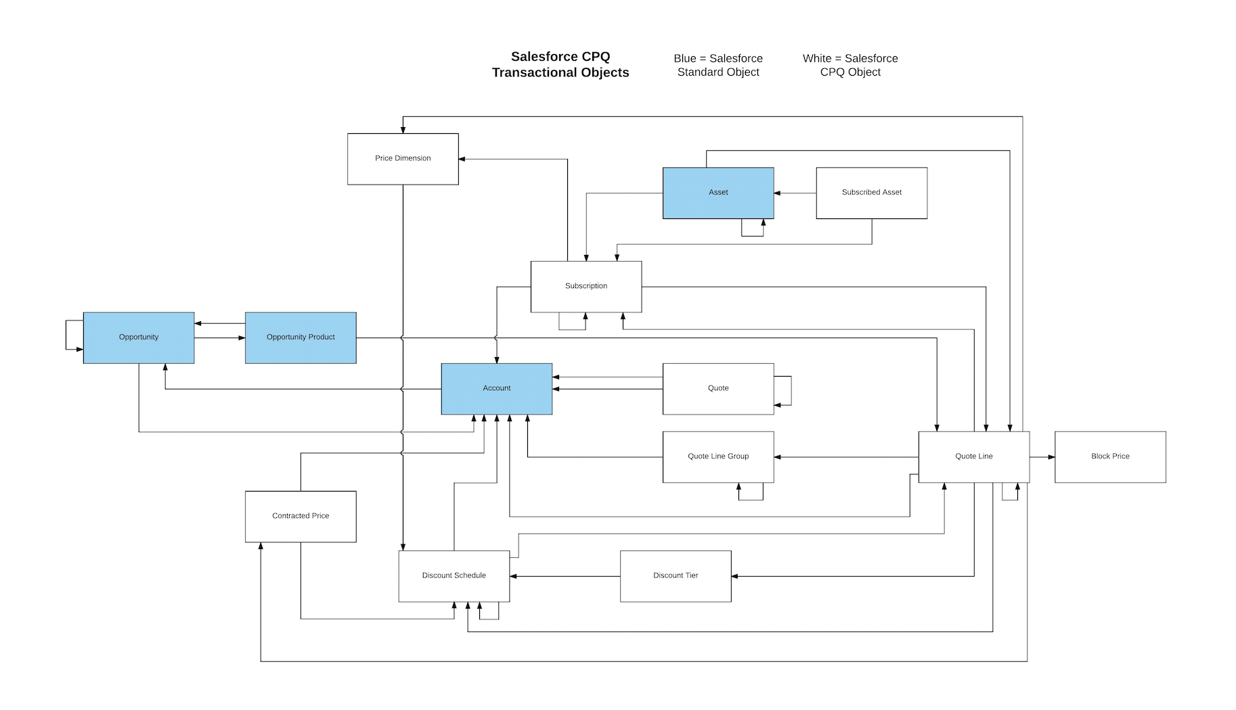](https://na74.salesforce.com/0PSo0000000IKRc)

## [Transition:](https://na74.salesforce.com/0PSo0000000IKRc)

1. [Using Data Loader](https://na74.salesforce.com/0PSo0000000IKRc)

### [Product2 :](https://na74.salesforce.com/0PSo0000000IKRc)

[Query for the product with productcode =’HD Bundle’ and update the following fields](https://na74.salesforce.com/0PSo0000000IKRc)

|  |  |
| --- | --- |
| [Product2](https://na74.salesforce.com/0PSo0000000IKRc) | [Product2](https://na74.salesforce.com/0PSo0000000IKRc) |
| [Product Code](https://na74.salesforce.com/0PSo0000000IKRc) | [Product Code](https://na74.salesforce.com/0PSo0000000IKRc) |
| [Product Name](https://na74.salesforce.com/0PSo0000000IKRc) | [Product Name](https://na74.salesforce.com/0PSo0000000IKRc) |
| [Product Family](https://na74.salesforce.com/0PSo0000000IKRc) | [Product Family](https://na74.salesforce.com/0PSo0000000IKRc) |
| [Description](https://na74.salesforce.com/0PSo0000000IKRc) | [Description](https://na74.salesforce.com/0PSo0000000IKRc) |
| [Product Configuration Type](https://na74.salesforce.com/0PSo0000000IKRc) | [Required](https://na74.salesforce.com/0PSo0000000IKRc) |
| [Price Editable](https://na74.salesforce.com/0PSo0000000IKRc) | [TRUE](https://na74.salesforce.com/0PSo0000000IKRc) |
| [Configuration Event](https://na74.salesforce.com/0PSo0000000IKRc) | [Always](https://na74.salesforce.com/0PSo0000000IKRc) |
| **[Option Selection Method](https://na74.salesforce.com/0PSo0000000IKRc)** | [click](https://na74.salesforce.com/0PSo0000000IKRc) |
| **[Pricing Method](https://na74.salesforce.com/0PSo0000000IKRc)** | [List](https://na74.salesforce.com/0PSo0000000IKRc) |
| [Default Quantity](https://na74.salesforce.com/0PSo0000000IKRc) | [1](https://na74.salesforce.com/0PSo0000000IKRc) |
| **[Subscription Pricing](https://na74.salesforce.com/0PSo0000000IKRc)** | [Fixed Price](https://na74.salesforce.com/0PSo0000000IKRc) |
| [Id](https://na74.salesforce.com/0PSo0000000IKRc) | [Id](https://na74.salesforce.com/0PSo0000000IKRc) |

### [Apttus Option group⇒ Feature.](https://na74.salesforce.com/0PSo0000000IKRc)

|  |  |
| --- | --- |
| [Apttus Option group](https://na74.salesforce.com/0PSo0000000IKRc) | [SB Feature](https://na74.salesforce.com/0PSo0000000IKRc) |
| [Name](https://na74.salesforce.com/0PSo0000000IKRc) | [Feature Name](https://na74.salesforce.com/0PSo0000000IKRc) |
| [MIn Options](https://na74.salesforce.com/0PSo0000000IKRc) | [MIn Options](https://na74.salesforce.com/0PSo0000000IKRc) |
| [Max options](https://na74.salesforce.com/0PSo0000000IKRc) | [Max options](https://na74.salesforce.com/0PSo0000000IKRc) |
|  | **[Option Selection Method:Click](https://na74.salesforce.com/0PSo0000000IKRc)** |

### [Production options⇒ Option.](https://na74.salesforce.com/0PSo0000000IKRc)

|  |  |
| --- | --- |
| [Apttus : Product Option Comp](https://na74.salesforce.com/0PSo0000000IKRc) | **[SB Product Option](https://na74.salesforce.com/0PSo0000000IKRc)** |
| **[Component Product](https://na74.salesforce.com/0PSo0000000IKRc)** | [Optional SKU](https://na74.salesforce.com/0PSo0000000IKRc) |
| **[Relationship Type](https://na74.salesforce.com/0PSo0000000IKRc)** |  |
| **[Sequence](https://na74.salesforce.com/0PSo0000000IKRc)** |  |
| **[Default](https://na74.salesforce.com/0PSo0000000IKRc)** |  |
| **[Quantity Modifiable](https://na74.salesforce.com/0PSo0000000IKRc)** | **[Quantity Editable](https://na74.salesforce.com/0PSo0000000IKRc)** |
| **[Required](https://na74.salesforce.com/0PSo0000000IKRc)** | [Required](https://na74.salesforce.com/0PSo0000000IKRc) |
| **[Parent Product](https://na74.salesforce.com/0PSo0000000IKRc)** | [Configured SKU](https://na74.salesforce.com/0PSo0000000IKRc) |
| **[Product Option Group](https://na74.salesforce.com/0PSo0000000IKRc)** |  |
| **[Min Quantity](https://na74.salesforce.com/0PSo0000000IKRc)** | **[Min Quantity](https://na74.salesforce.com/0PSo0000000IKRc)** |
| **[Max Quantity](https://na74.salesforce.com/0PSo0000000IKRc)** | **[Max Quantity](https://na74.salesforce.com/0PSo0000000IKRc)** |
| **[Default Quantity](https://na74.salesforce.com/0PSo0000000IKRc)** |  |
| **[Allow Cloning](https://na74.salesforce.com/0PSo0000000IKRc)** |  |
|  | [Type: Component](https://na74.salesforce.com/0PSo0000000IKRc) |
|  | [UnitPrice](https://na74.salesforce.com/0PSo0000000IKRc) |
|  | **[Discount (%)](https://na74.salesforce.com/0PSo0000000IKRc)** |
|  | **[Discount (Amt)](https://na74.salesforce.com/0PSo0000000IKRc)** |
|  | **[Price Editable](https://na74.salesforce.com/0PSo0000000IKRc)** |
|  | **[Product Description](https://na74.salesforce.com/0PSo0000000IKRc)** |
|  | **[Selected:true](https://na74.salesforce.com/0PSo0000000IKRc)** |
|  | [Discount Schedule](https://na74.salesforce.com/0PSo0000000IKRc) |
|  | [Bundle: True/False](https://na74.salesforce.com/0PSo0000000IKRc) |

### [PriceList => price book](https://na74.salesforce.com/0PSo0000000IKRc)

|  |  |  |  |
| --- | --- | --- | --- |
| [Price List](https://na74.salesforce.com/0PSo0000000IKRc) | [Price Book](https://na74.salesforce.com/0PSo0000000IKRc) |  |  |
|  |  |  |  |
| [Effective Date](https://na74.salesforce.com/0PSo0000000IKRc) |  |  |  |
| [Expiration Date](https://na74.salesforce.com/0PSo0000000IKRc) |  |  |  |
|  | [Is Active](https://na74.salesforce.com/0PSo0000000IKRc) | [Based on Expiration Date](https://na74.salesforce.com/0PSo0000000IKRc) |  |

### 

### [Price List Item => Price book entry.](https://na74.salesforce.com/0PSo0000000IKRc)

|  |  |
| --- | --- |
| [PriceList Item](https://na74.salesforce.com/0PSo0000000IKRc) | [Price Book Entry](https://na74.salesforce.com/0PSo0000000IKRc) |
| [Active](https://na74.salesforce.com/0PSo0000000IKRc) | [Active](https://na74.salesforce.com/0PSo0000000IKRc) |
| [Sequence](https://na74.salesforce.com/0PSo0000000IKRc) |  |
| **[Product](https://na74.salesforce.com/0PSo0000000IKRc)** | **[Product](https://na74.salesforce.com/0PSo0000000IKRc)** |
| **[Price List](https://na74.salesforce.com/0PSo0000000IKRc)** | **[Price Book](https://na74.salesforce.com/0PSo0000000IKRc)** |
| **[Charge Type](https://na74.salesforce.com/0PSo0000000IKRc)** |  |
| **[Price Type](https://na74.salesforce.com/0PSo0000000IKRc)** |  |
| **[Frequency](https://na74.salesforce.com/0PSo0000000IKRc)** |  |
| **[Price Method](https://na74.salesforce.com/0PSo0000000IKRc)** |  |
| **[List Price](https://na74.salesforce.com/0PSo0000000IKRc)** | **[List Price](https://na74.salesforce.com/0PSo0000000IKRc)** |
| **[List Price](https://na74.salesforce.com/0PSo0000000IKRc)** |  |
| **[Price Included In Bundle](https://na74.salesforce.com/0PSo0000000IKRc)** |  |
|  | **[Standard Price](https://na74.salesforce.com/0PSo0000000IKRc)** |
|  | **[Use Standard Price](https://na74.salesforce.com/0PSo0000000IKRc)** |
|  |  |

[These transition mapping makes data setup for CPQ system 2 ready with product and pricing setup. The Business Unit 2 can start with Quote creation in CPQ System 2 at the flip of record type assignment.](https://na74.salesforce.com/0PSo0000000IKRc)

## [Other Transition Options:](https://na74.salesforce.com/0PSo0000000IKRc)

1. [Batch Apex to automate the transition in the same SFDC env.](https://na74.salesforce.com/0PSo0000000IKRc)
2. [We can schedule using data loader.](https://na74.salesforce.com/0PSo0000000IKRc)
3. [External Third party tools like Node.js for transition setup.](https://na74.salesforce.com/0PSo0000000IKRc)

## [Automation:](https://na74.salesforce.com/0PSo0000000IKRc)

[Using data loader CLI, we can schedule the data extract and import with appropriate vlookup for data import across cross cpq objects and cross object custom fields.](https://na74.salesforce.com/0PSo0000000IKRc)

## [Order and Asset Integration:](https://na74.salesforce.com/0PSo0000000IKRc)

[Apttus use a custom order object for orders.](https://na74.salesforce.com/0PSo0000000IKRc)

[Steelbrick use a standard out of the box order object for orders](https://na74.salesforce.com/0PSo0000000IKRc)

[Orders needs to be centralized before transition from one CPQ to another. A button is created on Quote to create a standard out of the box order. This mimics the experience of the steelbricks order creation.](https://na74.salesforce.com/0PSo0000000IKRc)

[This button creates the order and order products from quote.](https://na74.salesforce.com/0PSo0000000IKRc)

[Migration of existing Assets and Orders:](https://na74.salesforce.com/0PSo0000000IKRc)

1. [use data loader to migrate existing assets and orders from CPQ model 1 to CPQ model 2. Mapping required](https://na74.salesforce.com/0PSo0000000IKRc)
2. [We can have an archival Job to migrate existing assets and orders from](https://na74.salesforce.com/0PSo0000000IKRc)

## [Technical Design:](https://na74.salesforce.com/0PSo0000000IKRc)

### [Components Created](https://na74.salesforce.com/0PSo0000000IKRc)

|  |  |  |
| --- | --- | --- |
| [API](https://na74.salesforce.com/0PSo0000000IKRc) | [Type](https://na74.salesforce.com/0PSo0000000IKRc) | [Description](https://na74.salesforce.com/0PSo0000000IKRc) |
| [createOrder](https://na74.salesforce.com/0PSo0000000IKRc) | [Visual Force page](https://na74.salesforce.com/0PSo0000000IKRc) | [Button on Quote to create Order from apttus CPQ](https://na74.salesforce.com/0PSo0000000IKRc) |
| [createOrderCtrl](https://na74.salesforce.com/0PSo0000000IKRc) | [Apex Class](https://na74.salesforce.com/0PSo0000000IKRc) | [Controller to create orders and assets from apttus quote](https://na74.salesforce.com/0PSo0000000IKRc) |
| [KSE1](https://na74.salesforce.com/0PSo0000000IKRc) | [Apex Class](https://na74.salesforce.com/0PSo0000000IKRc) | [Util class being used from createOrderCtrl](https://na74.salesforce.com/0PSo0000000IKRc) |
| [OrderUtils](https://na74.salesforce.com/0PSo0000000IKRc) | [Apex Class](https://na74.salesforce.com/0PSo0000000IKRc) | [Util class being used from createOrderCtrl](https://na74.salesforce.com/0PSo0000000IKRc) |
| [SchemaUtil](https://na74.salesforce.com/0PSo0000000IKRc) | [Apex Class](https://na74.salesforce.com/0PSo0000000IKRc) | [Util class being used from createOrderCtrl](https://na74.salesforce.com/0PSo0000000IKRc) |
| [SOQLUtil](https://na74.salesforce.com/0PSo0000000IKRc) | [Apex Class](https://na74.salesforce.com/0PSo0000000IKRc) | [Util class being used from createOrderCtrl](https://na74.salesforce.com/0PSo0000000IKRc) |
| [Asset.Proposal_Line_Item__c](https://na74.salesforce.com/0PSo0000000IKRc) | [Custom Field](https://na74.salesforce.com/0PSo0000000IKRc) | [Lookup quote line from asset/order](https://na74.salesforce.com/0PSo0000000IKRc) |
| [OrderItem.Proposal_Line_Item__c](https://na74.salesforce.com/0PSo0000000IKRc) | [Custom Field](https://na74.salesforce.com/0PSo0000000IKRc) | [Lookup quote line from asset/order](https://na74.salesforce.com/0PSo0000000IKRc) |